Attachment 1

Newmarket Green, Randwick

- Development Control Plan

Chapter E5
Randwick Development Control Plan 2013

February 2015
Incorporating draft changes for public exhibition (September 2015)

Newmarket Site, Randwick

Draft Development Control Plan

Chapter E5
Randwick DCP 2013

May 2014

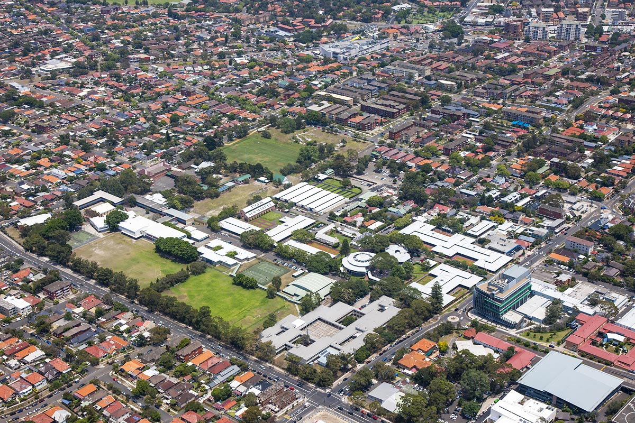

Contents
1 Introduction 1
1.1 Name of this DCP 1
1.2 Land to which this DCP Applies 1
1.3 Purpose of this DCP 2
1.4 Relationship to other Plans 2
1.5 Consent Authority 2
1.6 Application of this DCP 2
1.7 Procedures for Development Applications 2
1.8 Objectives 2
1.9 Stage 1 development applications 3
2 Vision, Principles and Indicative Concept 4
2.1 Vision 4
2.2 Development Principles 4
2.3 Desired Future Character 4
2.4 Indicative Concept Plan 8
3 Public Domain 11
3.1 Infrastructure 11
3.2 Street Design Controls 12
3.3 Street Network and Design 13
3.4 Open Space Network and Landscaping 16
3.5 Heritage 19
4 Design Controls 22
4.1 Building Height 22
4.2 Minimum Building Setbacks 24
4.3 Transport, Traffic and Parking 25
4.4 Building Design and Materials 27
4.5 Mixed Use Development 30
4.6 Utilities and Site Features 31
4.7 Affordable Housing
5 Environmental Management and Sustainability 33
5.1 Contamination 33

Figures

Figure 1 Land to which this DCP Applies 1
Figure 2 Character Precincts 7
Figure 3 Indicative Concept Plan 10
Figure 4 Stormwater system 12
Figure 5 Street Network 14
Figure 6 Open Space Network 17
Figure 7 Landscaping and Public Domain 18
Figure 8 Heritage Plan (and curtilage areas) 20
Figure 9 European Archaeological Heritage 21
Figure 10 Aboriginal Archaeological Heritage 21
Figure 11 Indicative Building Edge Heights in Key Areas 23
Figure 12 Specific Architectural Response 29

Tables

Table 1 Key Elements 8
Table 2 Indicative Street Dimensions 15
Table 3 Primary Building Setbacks 24
Table 4 Parking Rates 26

Introduction
This document provides a framework to guide development of the Newmarket Green site in Randwick identified as a ‘Key Site’ under Randwick Local Environmental Plan 2012.

Name of this DCP
The DCP has been prepared in accordance with the provisions of section 74C of the Environmental Planning and Assessment Act 1979 (the Act). The DCP was adopted by the Secretary of the Department of Planning and Environment on 30 March 2015.

Land to which this DCP Applies
The provisions of this chapter apply to development within the Newmarket Green site as shown in Figure 1. The site is generally bounded by Barker, Jane, Young, Middle and Botany Streets. Young Street and Middle Street dissect the site in a north-south and east-west direction respectively.
Figure 1 Land to which this DCP Applies
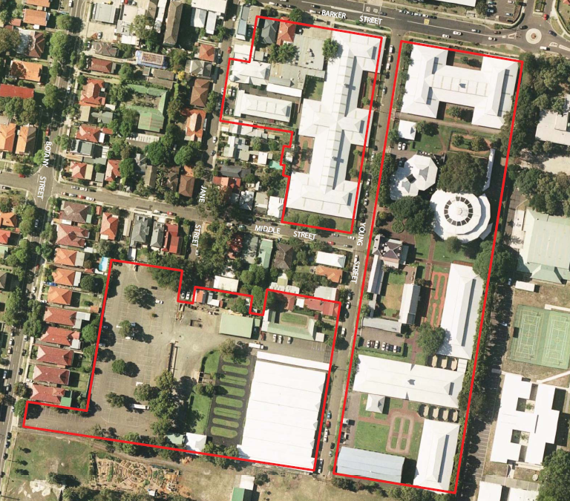

Purpose of this DCP
The purpose of this DCP is to guide future development of the Newmarket Green site by:
- Identifying the vision, development principles, key elements and indicative concept for the future development of the site
- Communicating the planning, design and environmental objectives and controls against which the consent authority will assess future development applications
- Providing for the celebration of heritage items and provision of open space
- Encouraging environmentally sensitive development and sustainability
- Ensuring the provision of infrastructure to service development of the site
- Promoting high quality urban design outcomes
- Providing for diverse housing including affordable housing.

This section of the DCP should be read in conjunction with:
- Part A- Introduction and Part B General Controls
- Other sections of the DCP for specific development types, locations or miscellaneous controls as relevant to any particular DA.

Relationship to other Plans
This DCP supplements the Randwick Local Environmental Plan 2012 by providing specific development guidance for the Newmarket Green site. Development within the site will need to have regard to this DCP as well as relevant provisions in the Randwick DCP 2013 as noted above.

Consent Authority
Unless otherwise authorised by the Act, Randwick City Council is the consent authority for development applications applying to the Newmarket Green site.

Application of this DCP
This DCP contains objectives and controls relating to various aspects of development at Newmarket Green. The objectives enable Council and applicants to consider whether a particular proposal will achieve the development outcomes established for the site. The consent authority may consider reasonable alternative solutions that achieve the overall vision, objectives and development principles as well as the specific objectives of the controls that demonstrate improved public benefits and design excellence can be achieved.

Procedures for Development Applications
Information requirements for development applications are set out in Part 2 of the Randwick DCP 2013. Notification of development applications will be undertaken in accordance with Part 3 of the Randwick DCP 2013.

Objectives
The objectives of this section are to ensure that future development:
- will result in an environmentally sustainable precinct
- exhibits design excellence and incorporates high quality materials and finishes
- provides for high quality publically accessible open space that responds to heritage values of the site
- responds to the heritage context of the site and the surrounding fine grain neighbourhood
- provides for housing types that meet the needs of key workers and students, including affordable housing
- respects the existing low scale residential character, adjoining schools and public open space
- incorporates adequate internal carriageway widths to provide a safe pedestrian and cycle network

Stage 1 development applications
Council’s preference is for a stage 1 development application (or concept application) to be submitted prior to the approval of any other development application. The stage 1 application shall include the following:
- proposed subdivision including public open space;
- how the permitted gross floor area is to be distributed throughout the site (on a block by block basis) consistent with the permitted FSR for the site under Randwick LEP 2013;
- road infrastructure layout including sections, design/treatment of pavements, verges and bicycle network (refer section 3.1) as part of a traffic management plan for the site;
- any off-site traffic management or public domain measures to be undertaken and staging of these works;
- car parking provision across the site consistent with Council’s DCP Section B7;
- relocation of any existing drainage infrastructure. In circumstances where relocation of infrastructure is not possible, alternative approaches such as identifying necessary easements and overland flow paths should be submitted; and
- identify opportunities for deep soil planting within development lots, including front setbacks (refer section 3.1)

Note: A stage 1 development application means a staged development application within the meaning of section 83B of the Environmental Planning and Assessment Act 1979 for the land to which this DCP applies.

Vision, Principles and Indicative Concept

Vision
Newmarket Green will be a high quality, socially cohesive and sustainable development that celebrates the unique landscape and built heritage of the site, in a manner that supports the growth of Randwick’s Education and Health Strategic Centre, through the delivery of open space, diverse housing including affordable housing and complementary uses.

Development Principles
To achieve this vision, development of the Newmarket Green site is to:
- Create new publically accessible open spaces that will act as gathering spaces and opportunities for passive recreation
- Ensure landscaping and the design of the public domain areas incorporate the retention of significant trees, where appropriate, to create a high quality urban environment
- Incorporate sustainability measures that reduce the site’s impact on the natural environment
- Provide for stormwater management to ensure no properties downstream of the development site will be adversely affected
- Strengthen the role of Newmarket Green as a contributor to housing and employment within the Education and Health Strategic Centre
- Provide a range of housing including affordable housing that will increase choice and diversity in the area
- Support the CBD-East Sydney light rail by providing commercial and residential floor space for a growing community
- Transition building heights in response to surrounding heritage items and the Struggletown Conservation Area
- Create high quality streets and public spaces that provide for safe and efficient movement of pedestrians, cyclists and vehicles through the site
- Improve the permeability of the neighbourhood by extending existing, and creating new a new street network
- Celebrate the site’s heritage through the adaptive reuse of the Big Stable and Newmarket House and the creation of public view corridors to and from these items
- Encourage neighbourhood-scale commercial activity along Barker Street and the site’s heritage items
- Provide for affordable housing to meet the needs of the local community and key workers.

Desired Future Character
Newmarket Green is defined by three distinct precincts. Each precinct has a distinct desired future character that is to be reflected in the design of built form and public domain. All development at Newmarket Green is to contribute to achieving the desired future character within each precinct.
The three precincts are shown in Figure 2 and are described below.

Barker Street Precinct
This is the most urban precinct reflecting the growth and scale of the Randwick Education and Health Strategic Centre. Focused on Barker Street, non-residential uses at the ground floor should create an active and vibrant interface along the street frontage. Active uses, with shop-fronts and outdoor seating, are encouraged on the ground floor.
A generous building setback (5 metre) to Barker Street will create a comfortable pedestrian environment, protected by awnings and street trees.
The public domain along Barker Street will enhance the pedestrian experience by providing:
- Street trees planted at regular intervals
- High quality block style pavers within the 5m setback
- Consistent awning and pedestrian scale lighting.
The balance of the Barker Street buildings will accommodate a range of uses to meet market demand and contribute to the Specialised Centre. This may include medical offices associated with the Hospital, and/or research or office space associated with the University of NSW, mixed with housing that will appeal to workers and users of the Specialised Centre – such as students and key hospital workers. Opportunities for partnerships with the adjacent Hospital and/or University should be encouraged, where possible.
Buildings range in height to respond to surrounding character. Close to Struggletown, buildings scale down in height to a maximum of 10 metres and are set back from the western boundary. Along Barker Street, buildings to a maximum height of 25 metres will provide a balance to the adjacent Hospital and create a prominent building alignment along Barker Street.
Transition of building height will occur between the lower scale existing residences adjacent to the site. Setbacks along Young Street are also encouraged, to allow for soft landscaping along the building edge and opening up of view corridors to Newmarket House.
Significant trees along the eastern boundary (adjoining Randwick Girls High School) and along Middle Street should be retained and building setbacks and footprints (including basements) designed to protect these trees and their root systems.
In the block on the western side of Young Street, south of the B1 Neighbourhood Centre zone, residential development will be integrated with the character of the surrounding residential properties in Struggletown Conservation Area. Built form in this block is designed to provide a fine grain element to Newmarket Green that responds to the low-scale character of Struggletown. Building heights will transition from lower scale along Middle Street, up to a higher scale at Young Street.
Buildings along Middle Street will incorporate setbacks to allow for the retention of significant trees. The setbacks will complement the transition in building heights to Struggletown, with a 2 storey building height at the street edge, stepping up and back to a height of 21 metres. This will create a transition to lower scale residences to the west along Middle Street. Adjacent to Newmarket House on the opposite side of Young Street, the eastern façade will incorporate a specific architectural response to ensure a high quality outlook from the park that complements Newmarket House and Gardens in the design, massing and selection of building materials and colours.
Eastern Precinct
This is the largest and most prominent space in Newmarket Green. It is characterised by the heritage listed buildings and landscapes that reflect the history of Newmarket Green, and which are to be celebrated through new open space and public domain areas.
A new public open space is located alongside Newmarket House and gardens, which incorporates the Sales Ring precinct. The focus of this open space will be the central Moreton Bay Fig Tree, as well as opportunities to celebrate the historic significance of the site through public art and interpretive features.
A second prominent public domain area will be the Big Stable and its curtilage at the southern end. An area of open space outside the Big Stable – known as Big Stable Square – will be defined by a formal shape to encourage public gathering and activity. Durable ground treatments, such as crushed gravel and porous paving, are encouraged to enable markets and other active uses in the Square.
Pedestrian connectivity and views between open spaces and public domain areas is to be encouraged through a north-south pedestrian link. Buildings in this precinct will range from 12 metres up to 25 metres, with low-rise elements adjacent to the retained heritage buildings and upper storeys set back. The following building envelopes shall be incorporated:
- Big Stable – Buildings should generally be set outside of the curtilage to create an outdoor civic space, to respect the scale of the Big Stable. Upper building elements to the north will be setback by at least 12 metres from the Big Stable, or so that the upper levels are entirely outside of the curtilage.
- Newmarket House and Garden – Building elements immediately adjacent to Newmarket House will be limited to 4 storeys within a transition zone. Upper storeys (up to 25 metres) will be setback from the heritage item, and focused in the centre of the site or along the eastern boundary.
Paine Reserve Precinct
Adjacent to the southern boundary of Newmarket Green, the focus is to maximise opportunities for passive surveillance of Paine Reserve whilst maintaining a transition of building heights to adjacent lower scale residential areas to the north and west.
Streets will be used to create view corridors, new access points to the site and to provide additional amenity to adjacent properties. A new street along the southern boundary will open up a new view corridor to the Big Stable from the west. A rear laneway along the western boundary abutting neighbouring properties fronting Botany Street, will provide a significant building separation to future development, benefiting the neighbouring properties to the west.
Built form and building heights in this precinct will be carefully considered to achieve good amenity and respond to surrounding heritage items, Paine Reserve and neighbouring sites:
- Mid to high-rise buildings (up to 25 metres) will be located along the southern boundary to create a prominent southern edge to the site and opportunities for passive surveillance of the neighbouring park. An articulated façade along the park edge will provide a high quality architectural finish when viewed from Paine Reserve. The northern edge of the building – facing terrace houses to the north – is to be set back by at least 2 metres from the street edge and has a reduced building height at the street edge (approximately 5 storeys). Upper floors are to be setback from the building edge.
- Building heights along the Young Street frontage will be scaled down (to approximately 4 – 5 storeys) to create a balance to the Big Stable. Upper storeys to 25 metres will be set back from Young Street. An architectural response will be required along the eastern facade of this building (Young Street frontage) that responds to, and provides an attractive view from, the Big Stable Square.
- Buildings along the western edge adjoining properties fronting Botany and Middle Streets will be a maximum of 10 metres so as to not dominate adjacent smaller scale dwellings. A two-storey difference in the relative ground level of the site and neighbouring properties to the west means the scale of buildings in this precinct will naturally appear reduced. On its eastern frontage along the Jane Street extension, the building will transition up to 18 metres, providing a balance to buildings on the opposite side of the street.
There is an opportunity to position a specific architectural or massing feature (2 storeys) on the building at the south western corner of the site to terminate views from Young Street / Big Stable Square down the new southern thoroughfare. The development block is set back from the new southern street to enhance this view.

Figure 2 Character Precincts
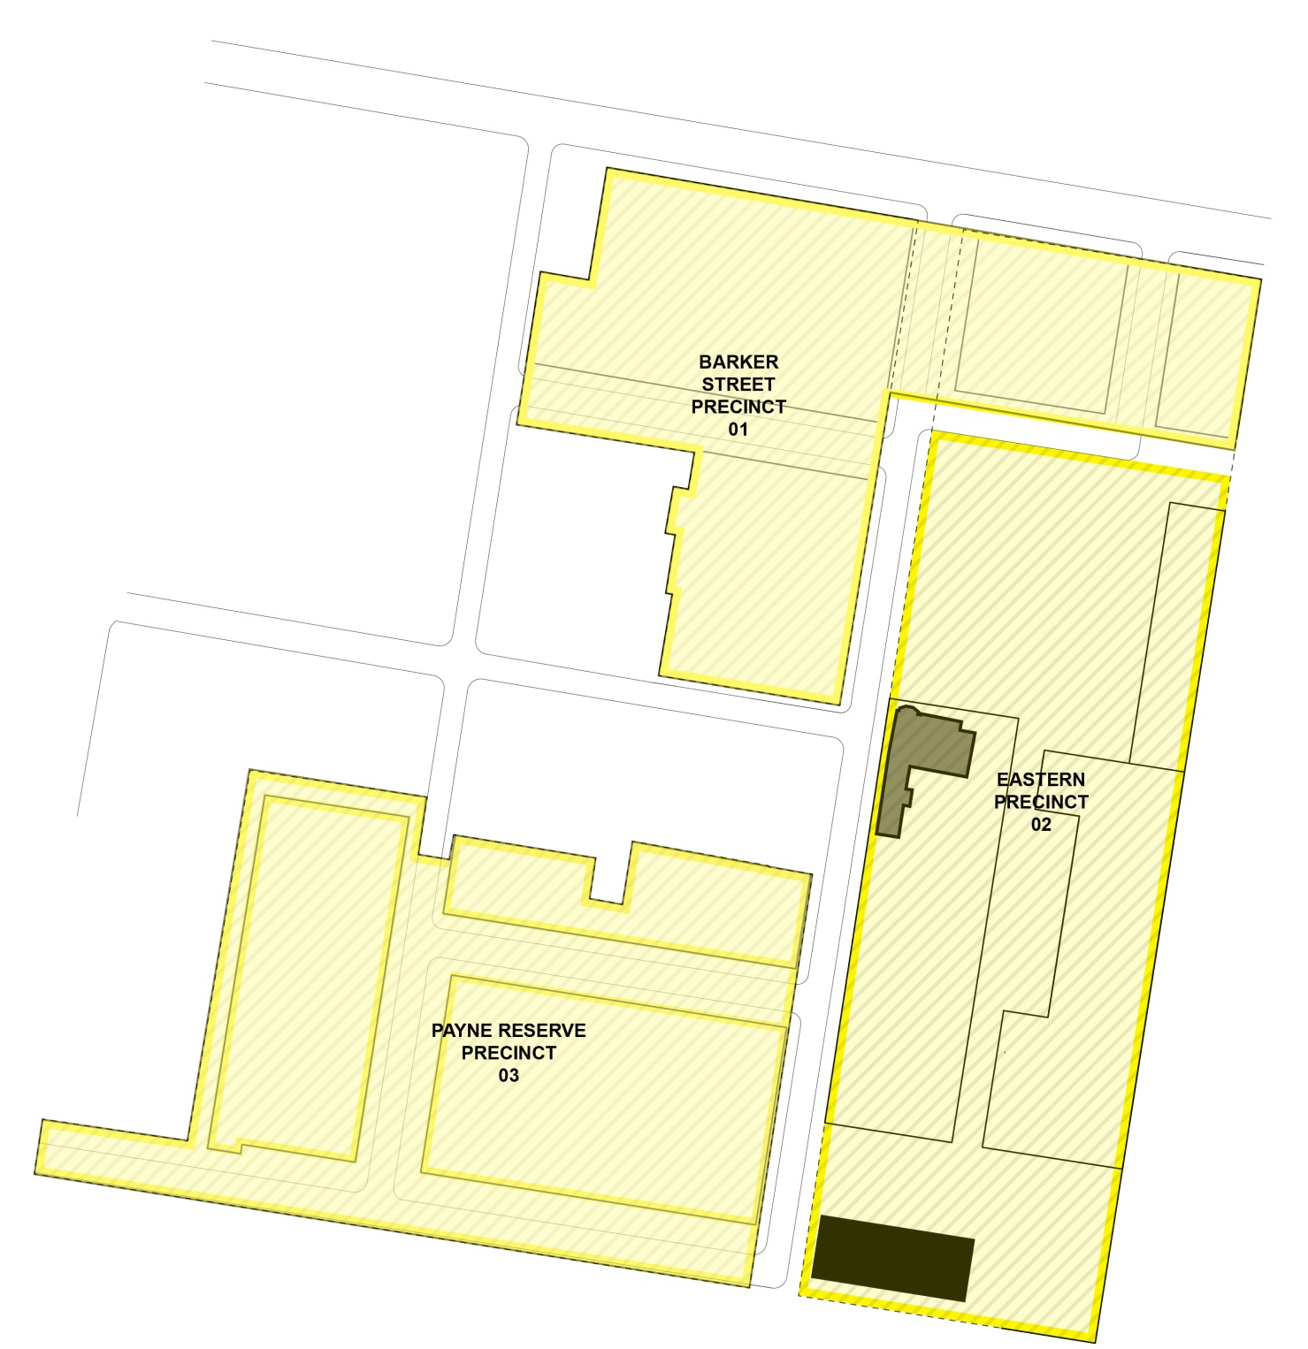
Paine Reserve
Precinct
03
PRECINCT BOUNDARY
NEWMARKET HOUSE
BIG STABLE BUILDING
SITE BOUNDARY

Indicative Concept Plan
Objectives
- Ensure that development of Newmarket Green occurs in a coordinated manner consistent with the vision and development principles for the site.
- Ensure the key elements of the site are delivered, whilst providing a degree of flexibility as to the final layout and design of the site.
- Ensure that the overall development complies with the maximum height and floor space ratio development standards for the whole site contained in Randwick LEP 2012.
Controls
- Development is to be generally consistent with the indicative concept plan in Figure 3 and key elements described in Table 1. Where variations are proposed, a development application shall demonstrate how the vision, development principles, key elements and relevant objectives are still able to be achieved.
Table 1 Key Elements
Element | Description
Residential community | - A transition from low to medium density residential development in the R1 General Residential Zone ensuring each block complies with the maximum 1.3:1 FSR across the whole site  - A range of housing types to broaden housing choice in the area, including more affordable options to meet market demand and accommodate key workers, students and other emerging demographic groups in the locality  - A mix of uses within the B1 Neighbourhood Centre zone at Barker Street that will attract pedestrian activity, vitality and contribute to the creation of a vibrant place that serves the needs of the local community
Affordable housing | - Provision of affordable housing across the site is required to accommodate key workers close to employment and services  - Affordable housing rented to low and moderate income households in accordance with the Randwick City Council Affordable Rental Housing Program and Procedures  - Affordable rental dwellings are designed and constructed to a standard which is consistent with other dwellings within Newmarket Green  - Affordable housing that contributes to a sustainable and stable local work force
Open space | - A new public open space with a minimum area of 5,000m2 comprising a single area that is not intersected by any other use to provide for a range of recreation opportunities with minimum dimensions of 66 metres by 76 metres. The configuration, location and right of public access to the public open space should be appropriate for its purpose.  - The public open space should be designed with two street frontages to provide good public access and opportunities for passive surveillance.  - New open space around key heritage items – the Big Stable and Newmarket House  - Design of landscaping and public domain areas to soften the appearance of the built form, create high levels of amenity and provide a focal point for passive recreation for the local community and respite for Hospital workers and visitors
Heritage | - Adaptive reuse of the Big Stable building and Newmarket House to encourage activities, including retail, cafes or restaurants, and the like  - Retention, celebration and interpretation of the historic Sales Ring within the new public open space  - Retention of significant trees that contribute to the site’s cultural significance  - Building and landscape design that complements on-site heritage items and the Struggletown Conservation Area
Built form | - Building heights ranging from 10 metres to 25 metres  - Low rise (10 – 12 metres) adjacent to Struggletown, the Big Stable, along Middle Street, and in response to the level change between Botany Street and the site  - Midrise (18 – 25 metres) in transition areas outside of significant views, along Barker Street, the eastern boundary, Paine Reserve and set back from key roads (Young Street) and open space  - Varied and dispersed building heights and setbacks to create an interesting, dynamic urban form that respects the scale of heritage items and adjacent properties
Movement network | - A series of new local streets and lanes to enhance connectivity, and provide views to key heritage items and open space  - A new southern thoroughfare adjacent to Paine Reserve to create a new access option through the site  - Extension of the existing Jane Street to the new southern thoroughfare to complete the original grid pattern of the locality  - A series of pedestrian and cyclist thoroughfares to enhance connectivity to surrounding areas, including the Prince of Wales Hospital and Paine Reserve
Sustainable Design | - Incorporate waste management and environmentally sustainable development  - Minimise greenhouse gas emissions  - Minimise water use and encourage water re use on the site  - Encourage less car dependency
Figure 3 Indicative Concept Plan
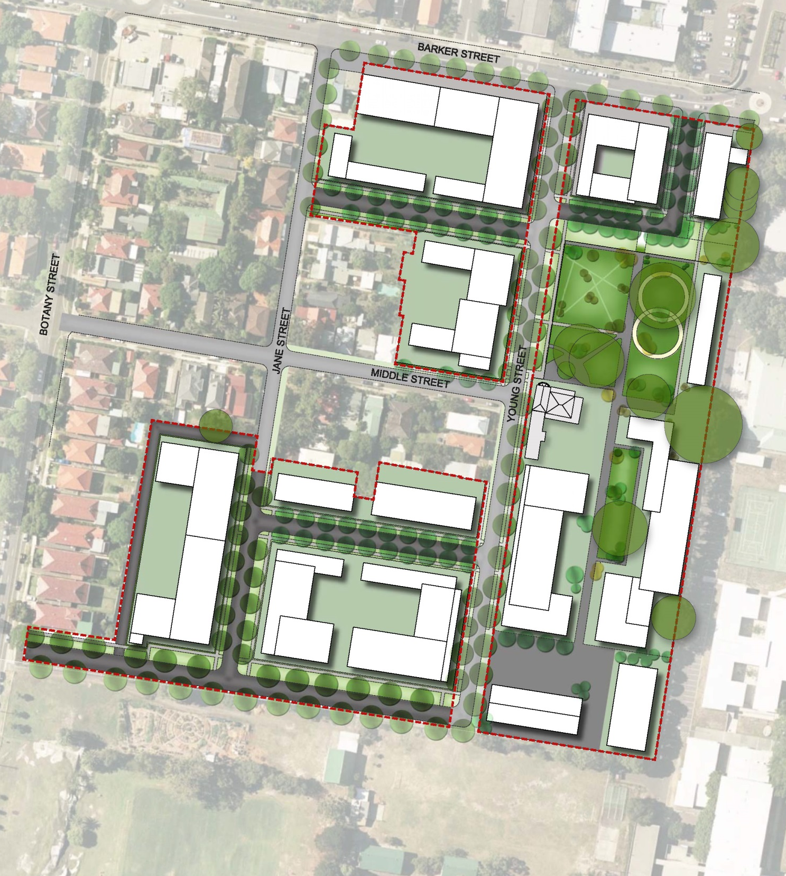
SITE BOUNDARY

Public Domain

Infrastructure
Any Stage 1 or concept development application submitted for the whole site must address all new infrastructure necessary for redevelopment of the site and changes to the existing infrastructure. The Stage 1 DA shall include sufficient documentation/evidence demonstrating compliance with DCP section B8- Water Management and Council’s Private Stormwater Code. The following matters shall also be addressed:

- The critical 1% AEP flood level must be established for all areas across the development site. Council has not undertaken any flood modelling for the subject catchment. The impact of a 1% AEP storm event on the proposed development will need to be fully assessed.

- Sufficient documentation/evidence indicating that the proposed development will not increase the depth of overland flow in areas outside the development site and that no property downstream of the development site will be adversely affected as a result of the proposed development for storm events up to the 1 in 100 year ARI event.

- In relation to the proposed site stormwater drainage system, sufficient documentation/evidence that the new system will not increase the depth of overland flow in areas outside the development site, will not adversely impact on Council’s stormwater drainage infrastructure and that no property downstream or upstream of the development site will be adversely affected as a result of the proposed development for storm events up to the 1 in 100 year ARI / 1% AEP event.

- The proposed internal roadways, any drainage easements and overland flow routes will drain the 1 in 100 year storm event and to consider personal and structure safety and the hazard factor, (product of velocity and depth of flow). This safety factor shall not exceed a value of 0.4 at any location. (i.e. VD< 0.4).

- The internal pipe system shall cater for the critical 1 in 20 year ARI / 5% AEP storm event with overland flows contained within the roadways or other suitable flow paths for up to the 1 in 100 year / 1% AEP storm event.

- Details showing indicative pipe sizes, pit locations, pipe locations and any associated drainage easements, inter-allotment drainage pipelines and associated inter-allotment drainage easements. Plans must identify the road network, pipe/pit network, catchments draining to the various pipes/drainage pits, location of potential overland flow paths, levels of properties adjacent to overland flow paths and level information on the roads in general.

- Diagrams showing the relocation of any existing drainage infrastructure. In circumstances where relocation of infrastructure is not possible, alternative approaches such as identifying necessary easements and overland flow paths should be submitted.

The existing stormwater system is shown in Figure 4 below:

Figure 4 Stormwater System
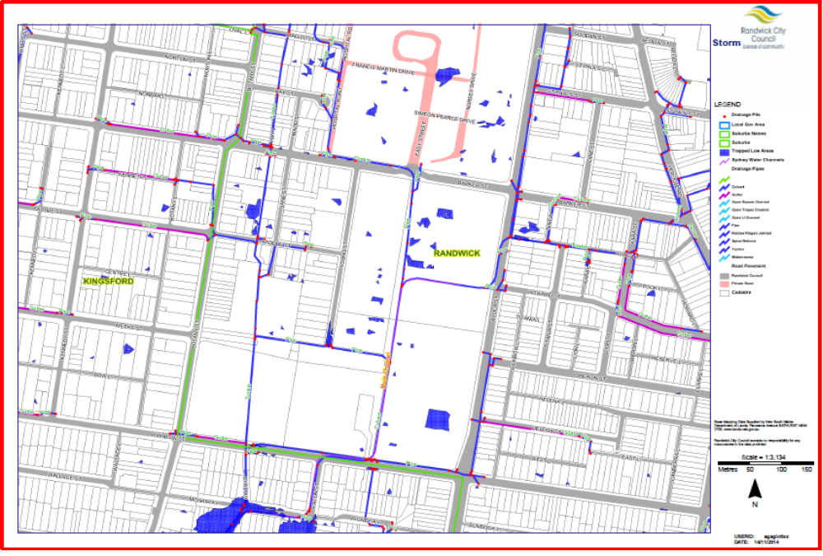

Street Design Controls
Any Stage 1 development application shall incorporate a traffic management plan demonstrating that the internal road system has sufficient capacity to accommodate the needs of the proposed development and safety of all users. In this regard the following details shall be included:
- A road safety audit shall be prepared and submitted for all internal roads. Separated cycle ways or shared paths should be investigated as part of this audit. One way streets will not be considered unless appropriate consultation with Council’s Traffic Committee and the Roads and Maritime Service has been undertaken and approvals have been granted in accordance with the Roads Act.
- Swept path details/analysis for a 9.5 metre garbage truck, (10.5 metre turning radius) for the provision of civil infrastructure for this site. The applicant shall note that satisfactory collection of domestic waste must be considered when designing the road network and or travel lane/footpath/parking lane configuration of the road network.
- For streets that have residential development fronting both sides of the street – streets shall be designed to provide a minimum of 2.3 metre wide parking lanes and 3.2 metre travelling lanes on both sides/ directions of the roads. The verge widths shall be a minimum of 3.0 metres in width on both sides, (with a minimum 1.5 metre wide footpaths to be constructed), creating a minimum 11 metre wide carriage way and a minimum 17 metre wide road reserve.

- For streets that have residential development fronting only one side, the parking lane on the other side may be omitted as no street parking demand is being generated. Thus narrowing the carriage way and road reserve by minimum 2.3 metres respectively.

- For one way streets, regardless that both sides have residential development fronting the street, the developer shall achieve a minimum 2.3 metre wide parking lane on the left hand side with a 3.2 metre wide travelling lane measured to the lip of the gutter. Thus a carriageway width being 5.95 metres be attained. With 3.0 metre wide road verges and 1.5 metre wide footpaths on both sides creating an 11.75 metre wide road reserve.

- The performance of intersections and the road network must be suitable for waste management vehicles, removalist trucks, emergency vehicles, construction traffic. Road intersections shall be designed with a minimum turning radius of 10.5 metres. Larger trucks such as 12.5 metre removalist trucks must be able to navigate the intersections without mounting kerbs, but may mount medians provided that the medians are to be suitably reinforced. All future development applications for civil infrastructure within this site must demonstrate compliance with this requirement.

3.3 Street Network and Design
Objectives
- Provide safe, efficient and legible movement of pedestrians, cyclists and vehicles.
- Design streets as spaces for people to enjoy, as well as move through incorporating high quality materials.
- Create a hierarchy of streets that promotes good connectivity with the existing street network.
- Promote direct vehicle access to the site from Young Street and Botany Street, and direct new vehicle movements away from Jane Street and Middle Street.
- Create a slow speed environment and naturally calm traffic through street design.
- Provide new on-street parking.
- Make adequate provision for footpaths, street trees, services and drainage.
- Enhance the current width and ‘local street’ function of Young Street.
Controls
- The street network including pedestrian and cycle infrastructure must be constructed in accordance with Council’s requirements prior to the issue of the first occupation certificate and the layout is to be generally consistent with Figure 5.
- New streets are to be generally consistent with the parameters in Table 2.
- Variations may be considered to the requirements in controls 1 and 2 above, where the above objectives and the following essential thoroughfare connections are satisfied:
  - A new thoroughfare along the southern boundary of the site connecting Botany Street to Young Street.
  - Extension of Jane Street connecting to a new southern thoroughfare.
  - A rear laneway along the western boundary of the site (where the site adjoins properties fronting Barker Street) to create additional building separation.
  - New east-west streets connecting Young Street and Jane Street.
- To cater for safe pedestrian movements across Barker Street, a pedestrian crossing shall be constructed across Barker Street to the satisfaction of Randwick City Council and NSW Roads and Maritime Services. Any signalisation of the pedestrian crossing shall meet the warrants for signals in accordance with the RMS document titled “Traffic Signal Design: Section 2- Warrants”.
- The applicant shall consult with Sydney Buses in relation to any temporary relocation of the bus stop along Barker Street (near the intersection with Young Street) that may be required during construction. The applicant shall reinstate the bus stop on Barker Street to the satisfaction of Sydney Buses.
- New streets as shown in Figure 4 including pedestrian paths and cycleways within the public domain shall be dedicated to Council.
Provide for a continuous pedestrian and cycling network through the site to connect to the broader street network.
Figure 5 Street Network

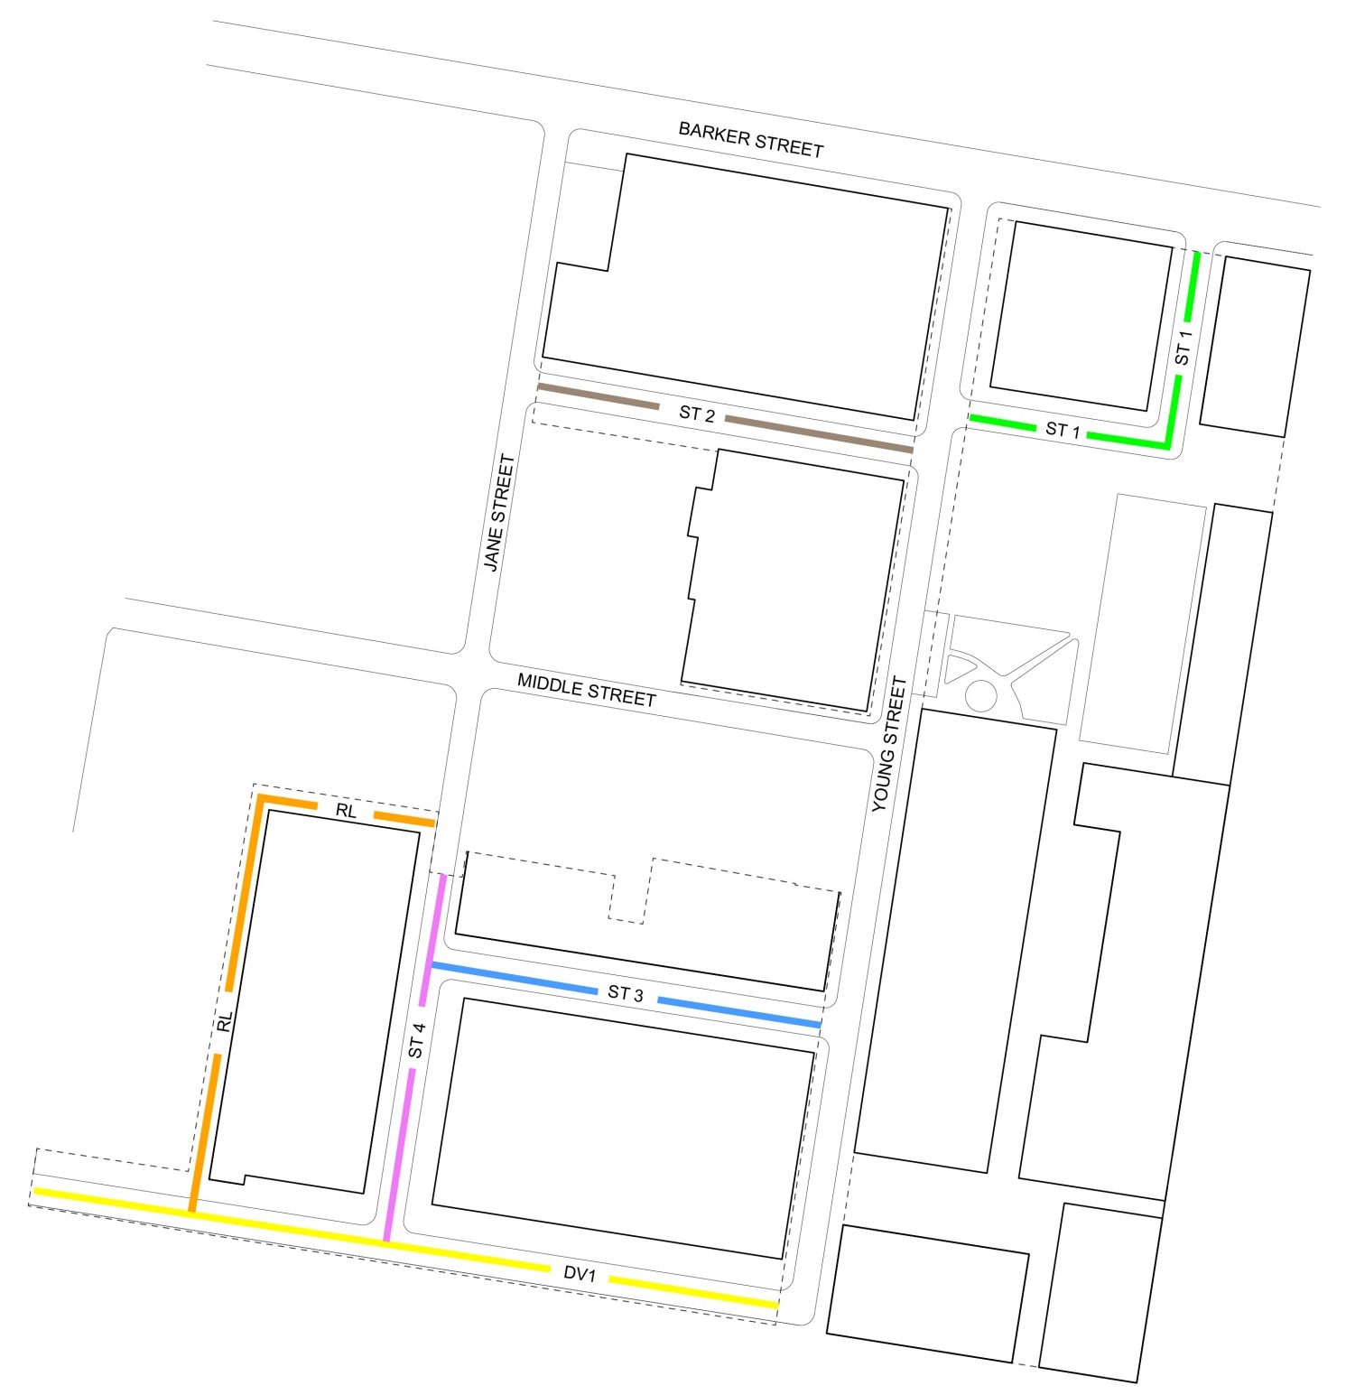
 | DRIVE 1 (DV1) SOUTHERN PARK EDGE
 | STREET 1 (ST1) BARKER STREET ENTRY
 | STREET 2 (ST2) EAST - WEST LINK
 | STREET 3 (ST3) EAST - WEST LINK
 | STREET 4 (ST4) JANE STREET EXTENSION
 | REAR LANE (RL)

Table 2 Indicative Street Dimensions
Street Type | Reserve⁽¹⁾  (min) | Carriage-way | Parking | Verge  (min) | Footpaths | Traffic Lanes | Movement type
DV1  Southern park edge  Botany Street to Young Street | 14.0m | 8.7m | 1 x 2.3m | 3.0m | 1 x 1.5m | Two travel lanes (3.2m), one in each direction | Slow, reduced speed (30km/hr design speed)
ST1  Barker Street entry  Barker Street to Young Street | 17m | 11.0m | 2 x 2.3m | 6.0m | 2 x 1.5m | One travel lane (3.2m), with two way traffic and passing opportunities | Yield*, reduced speed (15km/hr design speed)
ST2  East - west link  Jane Street to Young Street (north of Middle St) | 13.8m | 7.8m | 2 x 2.3m | 6.0m | 2 x 1.5m | One travel lane (3.2m), with two way traffic and passing opportunities | Yield*, reduced speed (15km/hr design speed)
ST3  East - west link  Jane Street to Young Street  (south of Middle St) | 13.8m | 7.8m | 2 x 2.3m | 6.0m | 2 x 1.5m | One travel lane (3.2m), with two way traffic and passing opportunities | Yield*, reduced speed (15km/hr design speed)
ST4  Jane Street extension  Jane Street to DV1 | 13.8m | 7.8m | 2 x 2.3m | 6.0m | 2 x 1.5m | One travel lane (3.2m), with two way traffic and passing opportunities | Yield*, reduced speed (15km/hr design speed)
RL  Rear laneway  DV1 to Jane Street | 6.0m | 5.0m | None | 1.0m | None | Two travel lanes (min 3m), one in each direction | Slow, reduced speed  (15km/hr design speed)
- The reserve width / verge width varies in some locations where specific building setbacks are to be achieved, or where building elements protrude into the setback to achieve a specific architectural response.
- At the entry to the site from Botany Street, the fixed position of existing properties to the north fronting Botany Street will require a reduction of the road reserve of 1 metre.
* Yield = single travel lanes require opposing vehicles to yield and utilise spaces between parked cars and driveways, etc.

3.4 Open Space Network and Landscaping
Objectives
- Create distinctive open space and public domain areas that respond to, and celebrate, the site’s cultural values, heritage items and significant streets.
- Provide a network of connected open spaces that are safe and secure for all users.
- Create and maintain significant view corridors to, and through, the site.
- Ensure high quality open space and public domain areas adjoin Newmarket House and the Big Stable.
- Design open space and public domain areas in a manner that promotes a range of passive activities and different degrees of social interaction.
- Ensure that landscaping adjacent to Newmarket House displays the qualities of elegance and simplicity.
- Facilitate pedestrian and cyclist connectivity through the site.
- Encourage landscape design that provides for increases in ecological and cultural value through natural, endemic vegetation and existing heritage landscapes.
- Maximise the interface between development and public open space to provide enhanced levels of residential amenity and casual surveillance of the surrounding public open space.
Controls
- Open space is to be provided generally in accordance with Figure 6.
- Public open space shall comprise a single area that is not intersected by any other use to provide for a range of recreation opportunities with minimum dimensions of 66 metres by 76 metres. The configuration, location and right of public access to the public open space should be appropriate for its purpose. The public open space should be designed with two street frontages to provide good public access and opportunities for passive surveillance.
- Public open space shall incorporate native vegetation and, where appropriate, shall meet the requirements of section B4- Landscaping and Biodiversity of Council’s DCP.
- Ensure buildings fronting the public open space are designed at ground level to provide adequate separation between units and the public domain to ensure the public nature/function of the public open space is not compromised. This may include raising of ground level apartments, setbacks and appropriate landscaping.
- All development is to be designed to retain significant views and allow for pedestrian connectivity identified in Figure 6.
- A view analysis is to be submitted with Development Applications that impact, or have the potential to impact, on significant views.
- Landscaping and public domain design, including retention of significant trees, shall generally be in accordance with Figure 7.
A landscape and public domain plan shall be submitted with all Development Applications proposing open space or public domain areas, and shall address the following (where appropriate):
  - The retention of significant trees accompanied by an arborist’s report for any pruning
  - Appropriate street tree planting spaced at regular intervals, on new streets
  - Appropriate lighting in the public domain
  - An appropriate response to the cultural landscape and heritage items, which investigates opportunities for the retention of existing timber benches, plaques, sandstone elements and gardens.
  - Rainwater infiltration to minimise run-off and minimal amount of hard surface area
  - Water efficient irrigation systems and use of non-potable water sources
  - Details of planting, paving, fencing, soil depth
  - Appropriate sunlight access
  - Provision of overland flow paths from north to south through the site
  - High quality materials and finishes including paving, stone, stainless streel and pre-cast concrete
Note: Refer to tree retention requirements of Clause 5.9 and 5.9AA of Randwick LEP.
Figure 6 Open Space Network
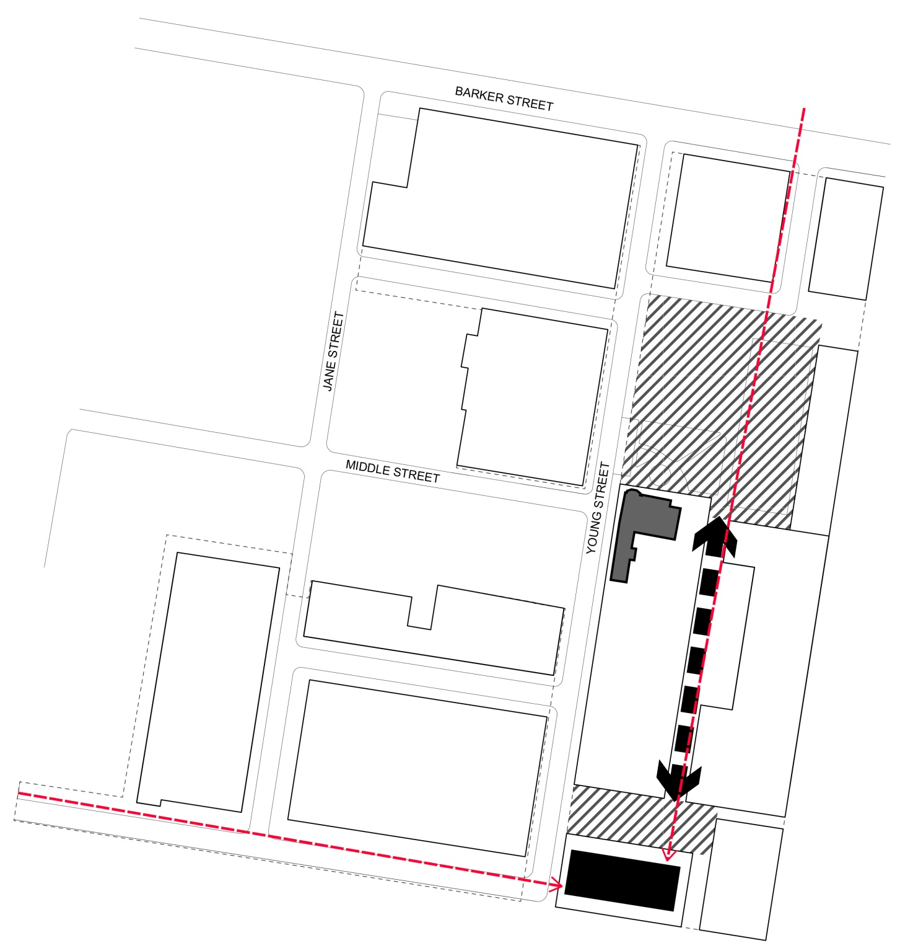
OPEN SPACE AREAS
NEWMARKET HOUSE
BIG STABLE BUILDING
PEDESTRIAN THOROUGHFARE
VIEW CORRIDOR
Figure 7 Landscaping and Public Domain
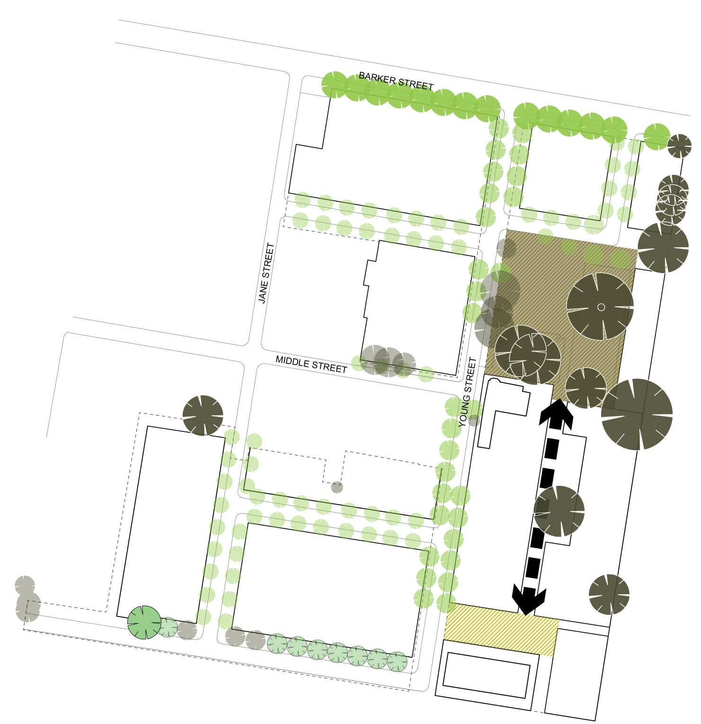
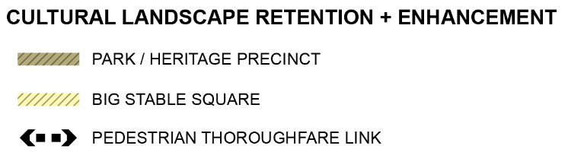
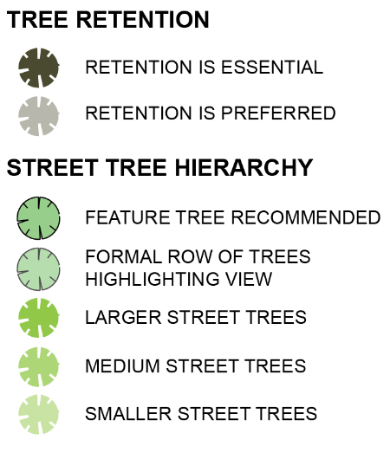

Heritage
Statement of Significance

Big Stable
A building of unusual function, high architectural quality and historic importance. It is an integral part of the Newmarket precinct, associated with the State’s racing industry for over one hundred years.

Newmarket House
Part of the historic Newmarket complex, a continuing focus of the State’s racing industry. Also of interest for its long association with Struggletown, on land originally purchased by Simeon Pearce and his brother. A fine example of a Grand Victorian house in good condition. Refer to State Heritage Register for further information.

Objectives
- Ensure the heritage significance of the site is conserved, appropriately managed and respected by all new development.
- Celebrate and interpret the heritage significance of the site in the design of buildings and open space.
- Provide opportunities for public access to, and appreciation of, retained heritage items.
- Create opportunities for adaptive reuse of Newmarket House and the Big Stable building.
- Ensure new development is designed to respond to the heritage character of the Struggletown Conservation Area.
- Ensure Aboriginal heritage is appropriately considered and managed through the development process.
Controls
- The Big Stable building and Newmarket House are to be retained. Adaptive reuse of these buildings must be in accordance with a Conservation Management Plan submitted with any Development Application that proposes development (including a new use) of these buildings. The Conservation Management Plan must demonstrate:
  - The proposed use is compatible with the significance of the heritage item
  - Provision for on-site interpretation has, or will, be made
  - That curtilage areas in Figure 8 are maintained and any development within the curtilage (including landscaping) is appropriately sited and designed to respond to the heritage items
  - That development, including alterations and additions, will maintain significant building fabric and building elements and allows for the appreciation of their significance
  - That consultation with relevant authorities has been carried out in accordance with the relevant legislation.
- The Moreton Bay Fig Tree within the Sales Ring precinct is to be retained within the public open space and incorporated into a landscape plan for the land in zone RE1. An arborist report shall be submitted prior to any development directly adjacent to the Moreton Bay Fig Tree to advise on development setbacks in order to ensure protection of the root system and viability of the Moreton Bay Fig Tree and any proposed pruning.
- All development within the Sales Ring precinct must be in accordance with an Interpretation Plan and conservation management plan prepared as part of a Development Application for that land. The Interpretation Plan shall outline the proposed method of interpretation of the Sales Ring through landscaping and design features that respond to its historic geometry and use (and may be incorporated with a landscape plan prepared as a requirement of control 2 above).
- Public domain features, such as the stone kerbing in the Struggletown Conservation Area, are to be retained where they contribute to the heritage significance of the Conservation Area.
- Development in areas identified as having High or Moderate Archaeological Sensitivity in Figure 9 will require an Archaeological Assessment to be carried out in accordance with relevant legislation and guidelines, as part of a Development Application.
- Development in areas identified as requiring further archaeological investigation or monitoring in Figure 10 will require appropriate assessments to be carried out in accordance with the relevant legislation and guidelines, as part of a Development Application.
Note: Refer to heritage requirements of Clause 5.10 of Randwick LEP.
Figure 8 Heritage Plan (and curtilage areas)
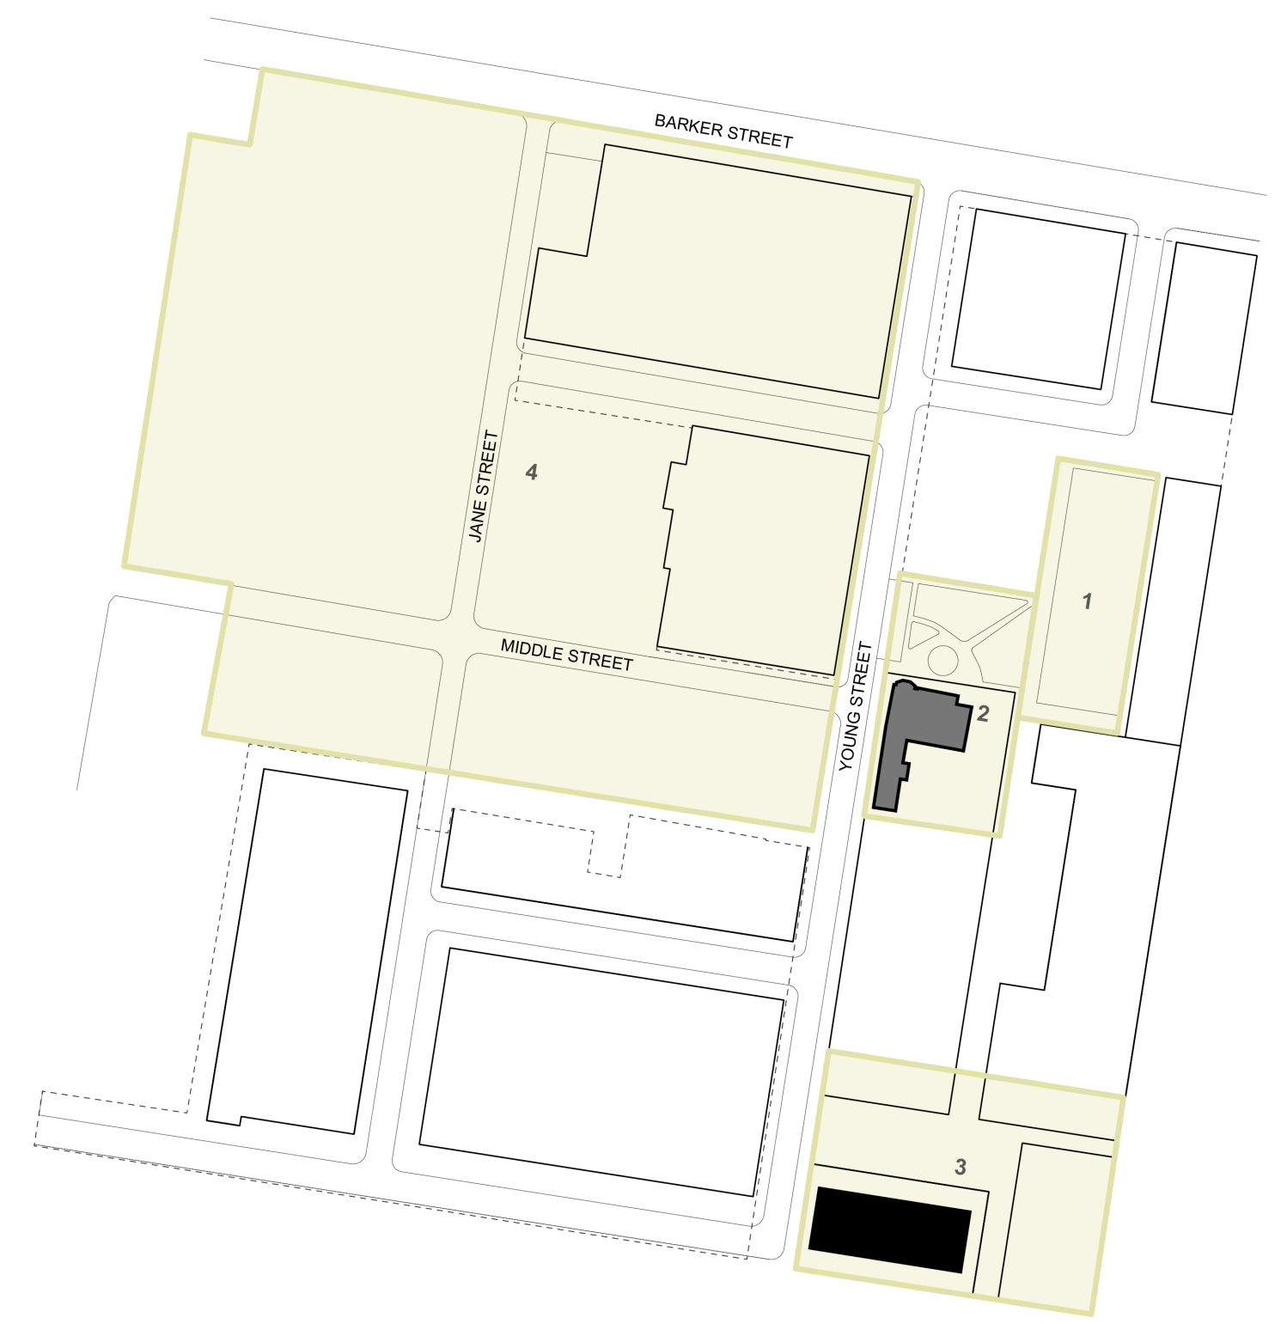
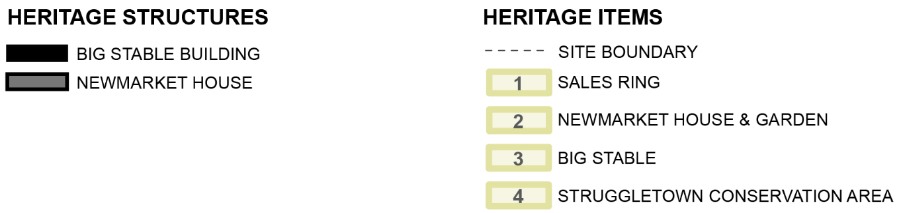
Figure 9 European Archaeological Heritage
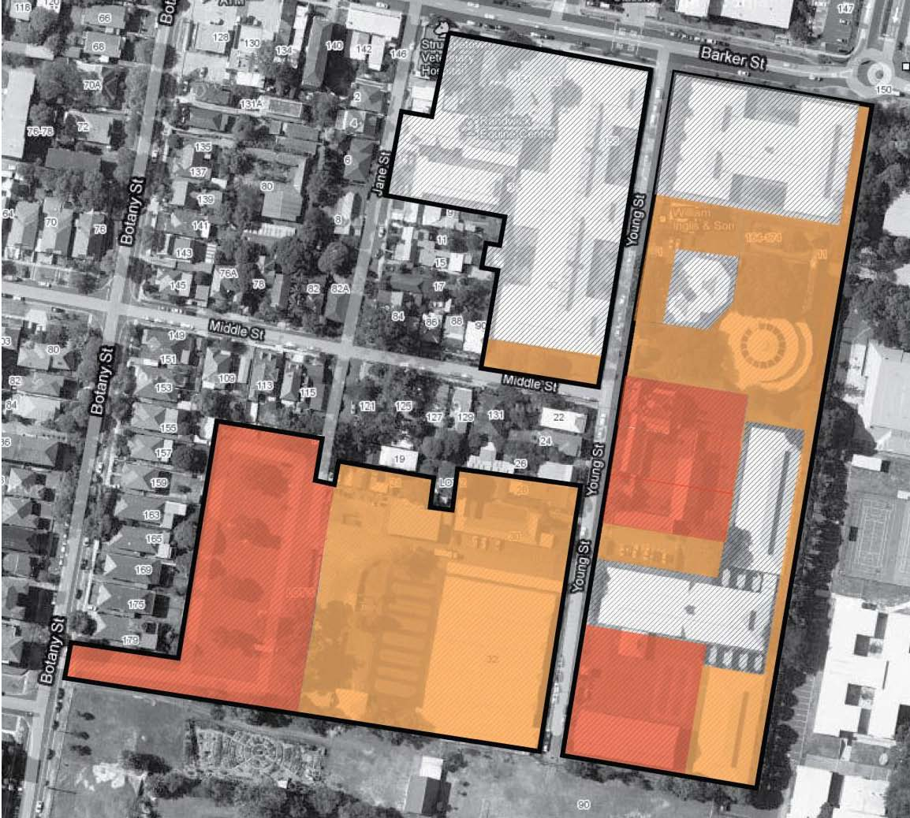
LOW ARCHAEOLOGICAL SENSITIVITY
MODERATE ARCHAEOLOGICAL SENSITIVITY
HIGH ARCHAEOLOGICAL SENSITIVITY

Figure 10 Aboriginal Archaeological Heritage
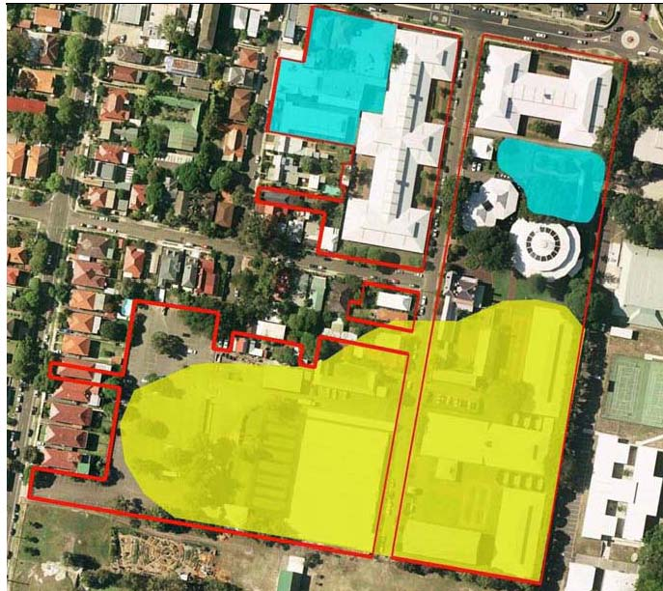
FURTHER INVESTIGATION MAY BE REQUIRED
POST DEMOLITION MONITORING MAY BE REQUIRED

4 Design Controls

4.1 Building Height
Objectives
- Ensure buildings transition in height to complement the scale of adjacent development.
- To consider solar access to the adjoining community garden, adjoining properties and on-site open space.
- Ensure building heights contribute to the creation of high quality and comfortable open spaces.
- Minimise the impact of development on heritage items on site.
- Ensure building heights in the immediate vicinity of the Struggletown Conservation Area and surrounding residential areas reflect the lower scale of development.
- Facilitate passive surveillance of streets and open space, including off-site open space at Paine Reserve.
- Allow for variation in massing and building heights to create visual interest, distribute the bulk of the building and minimise amenity impacts on adjoining properties and the streetscape.
- Allow for flood mitigation measures to be incorporated into the design of new buildings.
Controls
- To provide a height transition to key areas such as heritage items, the Heritage Conservation Area of Struggletown and on-site public open space, building heights at the street edge are to be generally consistent with Figure 11.
- Buildings directly adjacent to Newmarket House, which are located within the height transition area in Figure 11, are to be a maximum of 4 storeys. Upper levels (above 4 storeys) are to be set back outside the height transition area.
- Roof forms, plant rooms and lift overruns are to be designed to be simple compact forms that are visually unobtrusive.
Note: Maximum building heights (in metres) are set out in the Randwick LEP. State Environmental Planning Policy 65 – Design Quality of Residential Flat Development contains guidelines for building separation distances between upper levels and maximum floor to ceiling heights.

Figure 11 Indicative Building Edge Heights in Key Areas
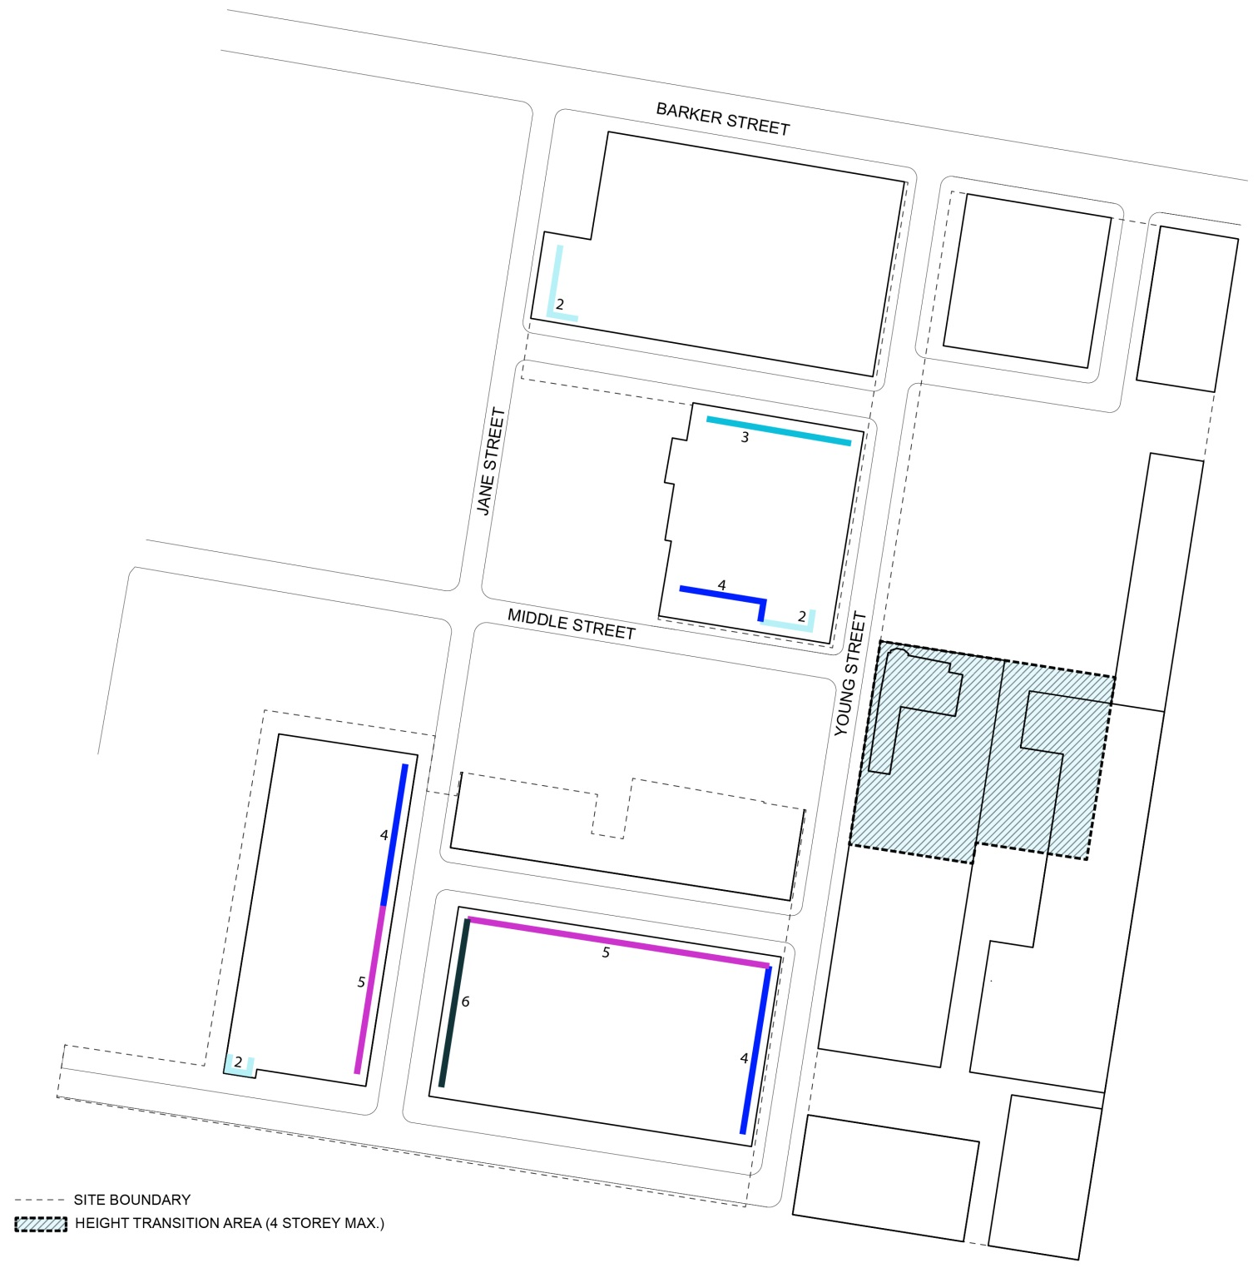
2
3
HEIGHT TRANSITION AREA (4 STOREY MAXIMUM)
MAXIMUM BUILDING EDGE HEIGHTS (STREET WALL)
2 STOREY
3 STOREY
4 STOREY
5 STOREY
6 STOREY

4.2 Minimum Building Setbacks
Objectives
- Control the appearance of bulk and scale in the built form.
- Ensure an appropriate scale around heritage items and within the Struggletown Conservation Area.
- Provide adequate separation between buildings and public domain for landscaping.
- Provide strong street edges, particularly along Barker Street and Paine Reserve frontage, and a clear delineation between public and private domain.
- Create view corridors and encourage the retention of significant views.
- Create private open space for residential uses within the private frontage of development blocks, including at ground level.
Controls
- Building setbacks are to be generally in accordance with Table 3 below.
- Buildings are to be sited to form a strong, predominantly continuous building edge to the primary street frontage or adjoining open space.
- Projections into front building setbacks for sun shading devises, fin walls and similar vertical screening are permitted, and should be setback at least 0.5 metres from property boundaries and from streets.
- Variations to the setback controls may be permitted to encourage building articulation and visual interest. Architectural elements permitted within the building setbacks include building attachments, balconies, terraces, porches, bay windows, planters and the like.
Table 3 Primary Building Setbacks
Setback from | Setback requirement (minimum)
Street frontages:
Barker Street | 5.0m
Jane Street | 5.0m (in B1 zone)  3.0m (in R1 zone)
Young Street (west side) | 3.0m
Young Street (east side) | 6.5m in B1 zone  3.0m in R1 zone
Middle Street | 3.0m (for 2 storey elements)  7.0m (for elements above 2 storeys)  Note: additional setback to accommodate tree retention on northern side of Middle Street required
New streets (ST1, ST2, ST3, ST4, DV1) | 2.0m (to ST2) in B1 zone  0.5m (to ST1) in B1 zone  3.0m (to DV1, ST2, ST3, ST4) in R1 zone  0.5m (to RL) in R1 zone
Interfaces:
Eastern boundary (interface with schools) | 1.0m  Note: additional setbacks may be required to accommodate tree retention
Southern boundary (interface with school) | 3.0m
Rear boundary (building interface with Struggletown) | 4.0m
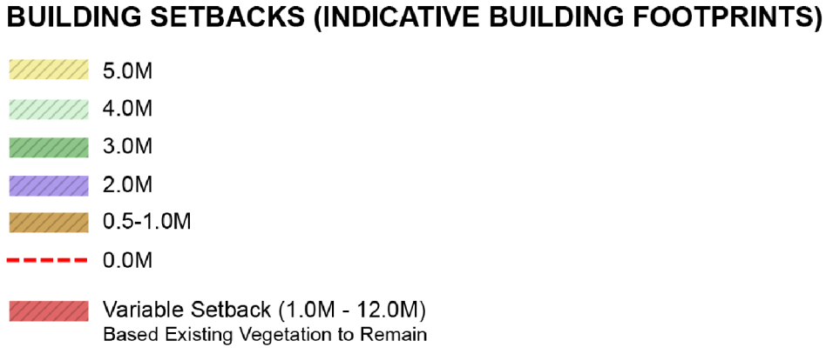

Transport, Traffic and Parking
Note: Applicants are advised to refer to Part B7 of Randwick DCP for further Transport, Traffic, Parking and Access controls to be addressed at Development Application stage. The controls in this section prevail where there is any inconsistency with the controls in Part B7 of Randwick DCP.
Objectives
- Reduce car dependence and encourage sustainable travel by encouraging the use of public transport, walking and cycling as modes of travel.
- Provide sufficient and convenient parking for residents and visitors with vehicular access that is simple, safe, and direct.
- Ensure appropriate provisions for service and delivery vehicles for non-residential uses, and minimise the use of on-street parking for loading where appropriate.
- Limit the amount of site area devoted to driveways and parking, and integrate these elements within the building design.
- Encourage sustainable travel and minimise the amount of on-site parking to be provided through a range of green travel arrangements.
Controls
Vehicle access
- Shared basements are encouraged to minimise the number of vehicular crossings. Vehicle access to basement car parking for buildings along the eastern boundary of the site shall be via a shared basement entry / exit from Young Street.
- Where required due to the adjacent flood conditions, basement car parking facilities should incorporate safe evacuation features in the event of a storm, flood or rainfall event.
Parking
Note: Applicants are advised that Part B7, Section 3.3 of Randwick DCP provides for exceptions to the parking rates in Randwick DCP where suitable and sustainable transport alternatives are considered and incorporated into the development. The parking rates in this section expand on the provisions of Section 3.3 by providing a framework for exceptions to the parking rates. To justify exceptions to the parking rates as indicated below, refer to the Green Travel Strategy prepared by Cardno (February, 2013) for further information about the preparation of a Green Travel Plan.
- Car parking is to be provided in accordance with the rates set out in Table 4.
- Where a Green Travel Plan (GTP) is submitted with a Development Application or has previously been approved for the proposed development, reduced car parking rates from those required in Part B7 of Randwick DCP may apply. Where the parking rates under a Green Travel Plan are not specified in Table 4, the provision of spaces must be explained and justified in the Green Travel Plan or the provisions of Part B7 will apply. If a Green Travel Plan is not prepared, Council’s existing controls apply with regard to the provision of parking.
- A Green Travel Plan prepared for the proposed development shall be generally consistent with the principles of the Green Travel Strategy prepared by Cardno (February 2013) enclosed in Appendix A.
- Shared car parking arrangements may be provided for mixed-use developments that contain residential and non-residential uses, where it can be demonstrated that maximum demand varies throughout the day. Justification for the variation in parking rates for the shared arrangement shall be outlined in a Traffic Report submitted with the Development Application.
- Car parking for ground floor non-residential uses may be provided as on-street car parking.
- Visitor parking for residential uses may be provided on-street and off-set against on-site visitor parking requirements.
- Tandem or stack parking (maximum two spaces) is permitted for residential and serviced apartment development.

Table 4 Parking Rates
Type | Rate – No Green Travel Plan | Rate – Green Travel Plan
Residential
Studio, Bedsit, 1 bedroom | In accordance with Part B7 of Randwick DCP | 0.5 space per dwelling
2 bedroom  (residential flat building) | In accordance with Part B7 of Randwick DCP | 0.8 space per dwelling
2 bedroom  (attached dwelling, e.g. townhouse) | In accordance with Part B7 of Randwick DCP | 1.2 space per dwelling
3+ bedroom | In accordance with Part B7 of Randwick DCP | 1 space per dwelling
Bicycle | In accordance with Part B7 of Randwick DCP | In accordance with ‘Residential’ GTP (Refer to Newmarket Green, Green Travel Strategy)
Motorcycle | In accordance with Part B7 of Randwick DCP | 1 space per 100 car parking spaces (Residential Flat Buildings)
Accessible spaces | Minimum 1-2% of all on-site spaces appropriately designed for use by people with mobility impairments/disabilities
Boarding houses and student accommodation | Note: SEPP (Affordable Rental Housing) 2009 contains controls for boarding houses, including parking requirements.
Seniors housing | Note: SEPP (Housing for Seniors and People with a Disability) 2004 contains controls for seniors housing, including parking requirements.
Retail and commercial
Commercial premises | In accordance with Part B7 of Randwick DCP | In accordance with ‘Work Place Travel Plan’ GTP (Refer to Newmarket Green, Green Travel Strategy)
Delivery and service vehicles | In accordance with Part B7 of Randwick DCP
Bicycle | In accordance with Part B7 of Randwick DCP
Motorcycle | In accordance with Part B7 of Randwick DCP

Building Design and Materials
Objectives
- Provide quality architecture through articulation and modulation to building facades, particularly buildings facing streets, parks and open space areas.
- Promote building design that makes a positive contribution to the urban character of the public domain.
- Ensure buildings respond to, and respect, heritage items through appropriate articulation, massing and the selection of colours and materials.
- Provide high quality architectural response in special areas that will enhance major view corridors.
- Ensure new residential development is designed to provide all occupants with visual and acoustic privacy.
- Ensure new development respects the privacy of adjoining properties.
- Allow for adaptable dwellings that can suit a range of residents including the elderly and people with a disability.
- Encourage the use of building materials that can withstand climatic extremes, are recycled and environmentally responsible.
- Encourage opportunities to incorporate sustainable design elements such as “green roofs” and “green walls” to improve amenity, air quality, ambient air temperature and building insulation, while maintaining aesthetic considerations and development feasibility.
Controls
- New buildings in the immediate vicinity of on-site heritage items, and new buildings adjoining the Struggletown Conservation Area, are to be designed to be compatible with, and respond to, the urban pattern and character of adjacent heritage items.
- Buildings shall include articulation to reduce bulkiness of buildings. Articulation may also occur on upper levels to provide visual relief and good design outcomes.
- Buildings are to be enhanced through a specific ‘architectural response’ at locations identified in Figure 12. Where a specific ‘architectural response’ is required, the building design is to incorporate special building massing, modulation and articulation. Where a specific ‘architectural response’ is required for a building adjacent to, or in view of, a heritage item, the building design should respond to, and enhance, the heritage character of the adjacent heritage item.
- The selection of materials and finishes of buildings directly adjacent to the Big Stable should respect, and respond to, the heritage item.
- The Barker Street frontage shall provide a strong street address with at least 70% of the façade as glass or another permeable material.
- Direct overlooking into the habitable rooms and private open space of other dwellings is to be minimised through building layout, and the location and design treatment of windows, balconies, screening devices and/or landscape elements.
- Windows of habitable room with a direct outlook to the window of a habitable room of another dwellings within 12 metres shall:
  - Be offset from the edge of one window to the edge of the other by a distance that is sufficient to limit view into adjacent windows, or
  - Have permanent screening along the windows, or
  - Have a minimum sill height of 1.7m above floor level, or
  - Have fixed obscure glazing on windows up to 1.7m above floor level, or
  - A combination of the above.
- Screens used to obscure views are to be:
  - Perforated panels or trellis with maximum 25% openings or solid translucent panels,
  - permanent, fixed and durable, and
  - designed and coloured to blend in with the development.
- Large windows shall be located on the north side of buildings, where possible, to allow for sun access. Large north-facing windows shall be shaded from summer sun by verandahs, balconies or roof eaves.
- A sample board or schedule of colours, materials and finishes, is to be submitted with a development application for a residential or mixed use development (new or major alterations and additions).
- Changes of colour and texture should be used to complement façade articulation.
- Building design and layout shall minimise the transmission of noise by separating quiet areas such as habitable rooms from common areas, parking areas, vehicle driveways and other noise generating development.
- Building design is to consider the provisions of the NSW Residential Flat Design Code, and in particular achieve a minimum of 2 hours direct sunlight between 9 am and 3 pm in mid-winter to living rooms and private open spaces for at least 70% of apartments.
- Buildings along the eastern boundary which do not have a direct street address shall have a clear ‘pedestrian address’ and be designed to have windows and doors fronting on to the public realm. Building design shall be integrated with a way-finding strategy to ensure it is easy to locate buildings that do not have direct street address.
- Each development block shall incorporate adequate design variation so that the site is not interpreted as a single development or community. The architectural response for each development block shall demonstrate variability from other development blocks at the site including the design of the public domain.
- Buildings shall incorporate the following principles to allow for adaptive use over time:
a) internal walls that can be easily removed or adjusted
b) locating services so that they do not impede future conversion to different configurations
c) ability to provide separate occupation of parts of units e.g dual key access from a shared private lobby
Note: ‘Architectural response’ is generally a reference to the enhanced visual appearance of a building through unique building massing, modulation or articulation in response to its special location – at the end of an important view corridor, alongside a heritage item or open space. The appropriate architectural response is to be determined on a case-by-case basis during the detailed building design. Building features that can be used to provide a specific ‘architectural response’ include, but are not limited to, building entries, architectural roof features, exaggerated floor to ceiling heights, building articulation, stepped massing, facade projections, and selection of particular materials, colours and textures, fenestration, balconies and balustrades, awnings, planters, pergolas, boundary walls, fences etc.

Figure 12 Specific Architectural Response
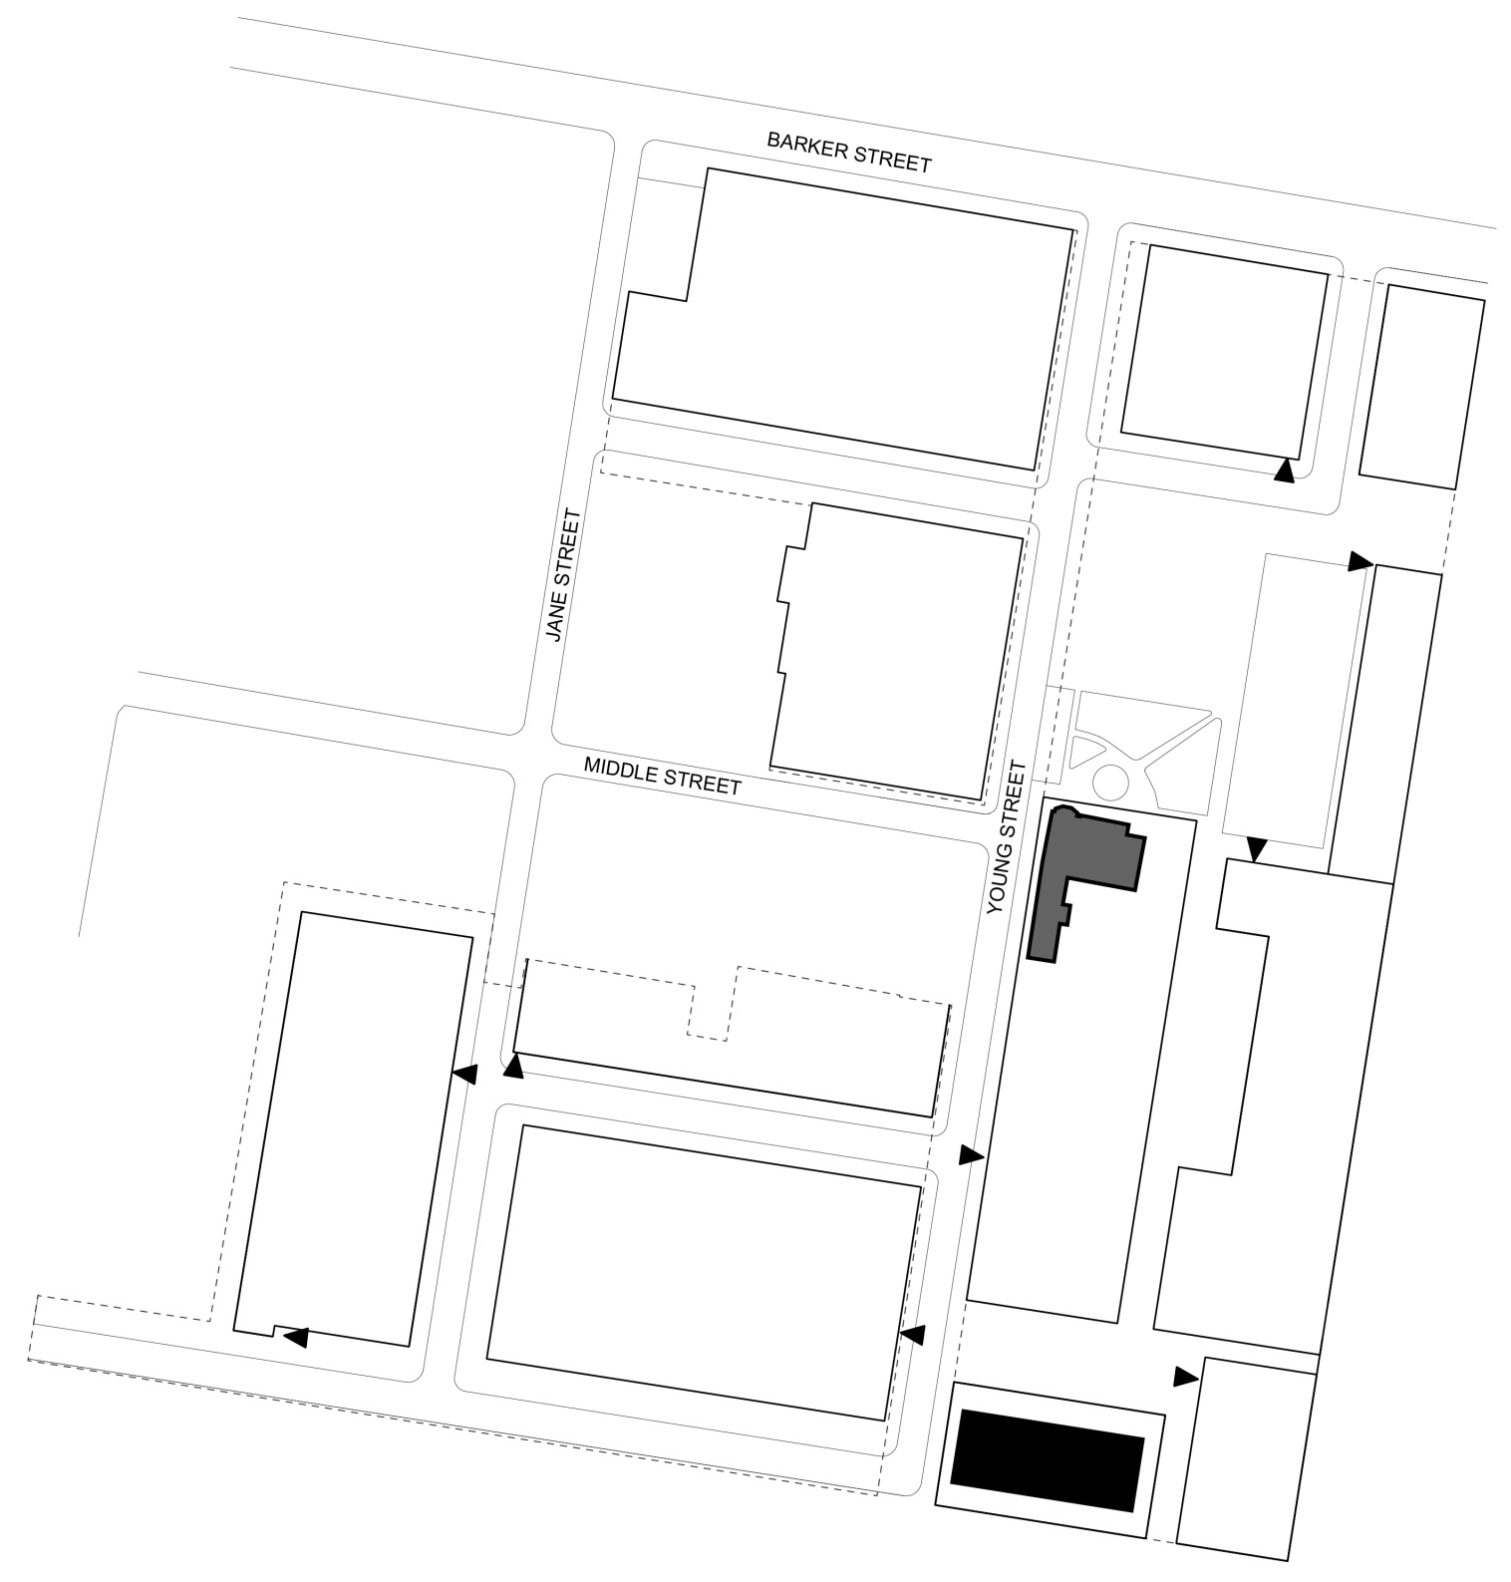

Mixed Use Development
Objectives
- Promote an active neighbourhood centre by encouraging mixed business, office, medical, retail and residential development in a more ‘urban’ environment along Barker Street.
- Attract pedestrian activity along key pedestrian thoroughfares and open space.
- Promote activity and urban vitality within the public domain, and encourage interaction between people at ground level.
- Ensure non-residential uses do not adversely impact the amenity of residential uses.
Controls
- Non-residential or activity-generating uses along the Barker Street frontage are to be encouraged, as well as in the adaptive reuse of Newmarket House and the Big Stable. Uses that spill onto the adjacent footpath or public domain, such as outdoor dining, are to be encouraged in these areas.
- The ground floor level at the Barker Street frontage shall have predominantly glass facades and shop fronts that allow for additional height to contribute to the activated street edge, and be at least 4.5 metres in height.
- Awnings are to be provided over the public footpath along Barker Street and shall be:
  - A minimum height of 3 metres above the footpath
  - A minimum depth of 3 metres from the building façade
  - At least 600mm from the edge of the road/kerb.
- Entry to non-residential ground floor premises is to be at the same level as the public footpath. Access steps, ramps and split footpaths should be avoided. Where entry to Newmarket House or the Big Stable is not possible at the same level as the adjacent public footpath or public domain, the requirements set out in the Conservation Management Plan for the adaptive reuse of these buildings shall take precedence (this may require access ramps).
- Residential entries and vertical circulation are to be clearly demarcated and separated from commercial entries and circulation. Residential entries should be clearly visible and directly accessible from the street or public domain.
- Commercial service areas including loading docks and waste areas, are to be separated from residential access, service areas and primary outlook, and are to be appropriately screened from the street. Loading docks and services areas shall be located to minimise adverse visual impact on the public realm.
- A design justification statement must be submitted with any Development Application that does not comply with the relevant signage policy of Randwick City Council. The statement must demonstrate the signage is consistent with the general objectives of the policy.

Utilities and Site Features
Objectives
- Ensure all dwellings and non-residential premises are adequately serviced.
- Ensure that facilities are of a sufficient size to meet the needs of occupants (and the garbage/recycling collection service in the case of waste facilities).
- Locate site facilities to be accessible, functional and unobtrusive from the streetscape.
- Provide adequate screening to air-conditioning units and noise-generating facilities.
- Provide usable storage space for new development, as required.
Controls
- A storage area of at least 8m³ is to be provided for each dwelling either within the dwelling or in a garage or basement.
- Waste storage areas for garbage and recycling must be sufficient in size to satisfy Randwick City Council’s waste collection requirements, and shall be integrated with the development and screened from public areas. In residential flat buildings, waste storage areas are to be provided:
  - In a centralised waste room in the basement that is accessible to garbage compactors and appropriately screened, or
  - In a facility where bins can easily be placed on the kerb for collection, away from the front of the development and appropriately screened.
- Mail boxes are to be located in accordance with the delivery requirements of Australia Post.
- Reticulated gas is to be made available to all residential development. Water and sewer connections are to be provided in accordance with Sydney Water.
- Electrical reticulation is to be underground. Where required, meter boxes are to be appropriated screened from the street and positioned in accordance with the energy service provider.
- Telephone lines and broadband internet is to be installed in accordance with the service provider.
- A single common television/radio antenna (or other type of communication reception device) is to be provided to service all dwellings and is to be suitably screened.
- Buildings along the eastern boundary which do not have a direct street address shall be serviced either underground (via basement level parking) or be accompanied by a Waste Management Strategy that outlines arrangements for waste storage.

4.7 Affordable Housing
Objectives

- Provide for affordable housing across the site to accommodate key workers close to existing employment and services.

- Recognise the importance of providing affordable housing on site to support the growth and function of the Randwick Education and Health Strategic Centre.

Controls

- Provide a minimum of 5% of all residential accommodation on site as affordable housing

- Affordable housing is rented to low and moderate income households in accordance with Randwick City Council Affordable Rental Housing Program and Procedures

- Affordable housing is designed and constructed to a standard which is consistent with other residential accommodation within Newmarket Green

Note: Affordable housing as defined by the EP&A Act means housing for very low income households, low income households or moderate income households, being such households as are prescribed by the regulations or as are provided for in an environmental planning instrument.

Affordable housing in this section refers to, but is not limited to, the provision of key worker housing, housing to assist people on low to moderate incomes in locations near to where they work. It is specifically targeted to essential service workers such as police, fire and ambulance, health services, childcare workers, education and community support services who make a vital contribution to our local economy and our workforce sustainability.

The need for affordable housing

The Council recognises the need to provide for affordable housing in the community and a diverse range of housing types to maintain a sustainable and stable labour force. In 2006, Randwick City Council adopted an Affordable Housing Policy and in 2007 an Affordable Housing Strategy and Action Plan designed to keep a mix of residents in our City. The policy and strategy affirms Council’s support in the provision of affordable housing in the community, particularly for those employees earning low to moderate incomes, who provide essential services to the local community.

Newmarket Green is adjacent to the Randwick Education and Health Strategic Centre. Significant employment growth in health, education and research is predicted for the Centre which will continue to generate demand for housing including for low income workers and/or key workers. Given its strategic location, Newmarket Green provides a unique and rare opportunity to address this increasing demand to support the growth and function of the Strategic Centre.

5 Environmental Management and Sustainability

5.1 Contamination
Objectives
- To ensure adequate procedures and controls for the identification and assessment of contamination that may increase risk to human health on the Newmarket Site and to minimise potential impacts on the environment.
- To ensure that if such contamination is identified, proper precautions for managing the risk to human health and the environment from the contamination are implemented prior to development so that the land to be developed is suitable for the proposed use.
Note: Applicants are advised of the following documents were prepared by the proponent as part of the planning proposal for the site:
- Preliminary (Phase 1) site investigations by E3 Consulting Australia for Precincts A, B and C, dated December 2010 and January 2011.
- Peer review Site Audit Report and non-statutory Site Audit Statement (no. 0503-1010) prepared by JBS, dated May 2011.
Controls
- Development applications shall adequately address and investigate site contamination including groundwater contamination and demonstrate compliance with the following:
- State Environmental Planning Policy (SEPP) No. 55,
- Randwick Council’s Contaminated Land Policy 1999,
- Land Management Act 1997,
- Contaminated Land Planning Guidelines 1998 (published by the Department of Urban Affairs and Planning and the Environment Protection Authority).
- Development applications shall be accompanied by preliminary site investigation(s), detailed site investigation(s) and details of remediation as may be necessary to demonstrate the land is, or can be made, suitable for the intended use. (Applicants are advised a Phase 1 preliminary site investigation has been carried out for the whole Newmarket Green site).
- The land subject to the development application shall be remediated, validated and certified in accordance with the documents listed in control (1).
- Remediation of the land, the subject of the development application must be completed to the satisfaction of the consent authority prior to the carrying out of any development on the land.
Note: State Environmental Planning Policy 55 – Remediation of Land and the associated SEPP 55 Guidelines outline the requirements for assessment and/or remediation of contaminated sites.

